**PROJECT-2 AMAZON PRIME(Edureka)**

**NAME: MEERATH KONAPALLI**

**GMAIL: meerathkonapalli99@gmail.com**

Amazon Prime is a paid subscription service from [Amazon](https://en.wikipedia.org/wiki/Amazon_(company)) which is available in various countries and gives users access to additional services otherwise unavailable or available at a premium to other Amazon customers. Services include same, one- or two-day delivery of goods and streaming music, video, e-books, gaming and grocery shopping services.

**Header:** Header consists of **Home, Store, Channels, Categories (with dropdown), My Stuff, Search and user log in details.**



**Home page.** The place to inform your users of the benefits they will find, show them the capabilities, mesmerize them by the looks and promises of entertainment. The Home section highlights movies, TV shows, sports programs, and other categories of content, and is customized according to each user’s preferences

Home consists of Image sliders of TRENDING MOVIES.

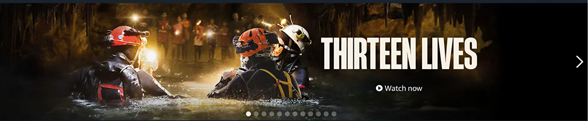

When we bring courser on to the image we can see the title of the movie, some description on the movie, watch now button, watchlist, and details. 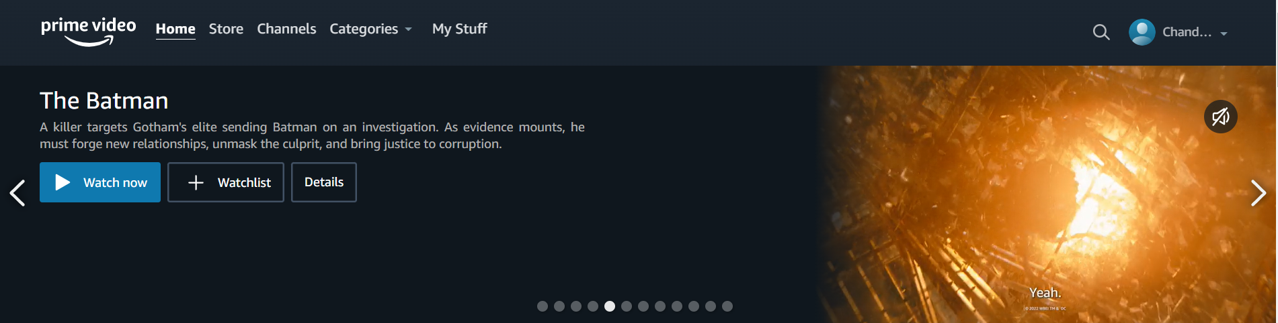

When we click on the image it will redirect to other page on new tab, and this page consists of some description of that movie, watch button, download button, IMDB Rating, available languages, duration of the movie.

On right side bottom we can see some options like share, feedback, get help.

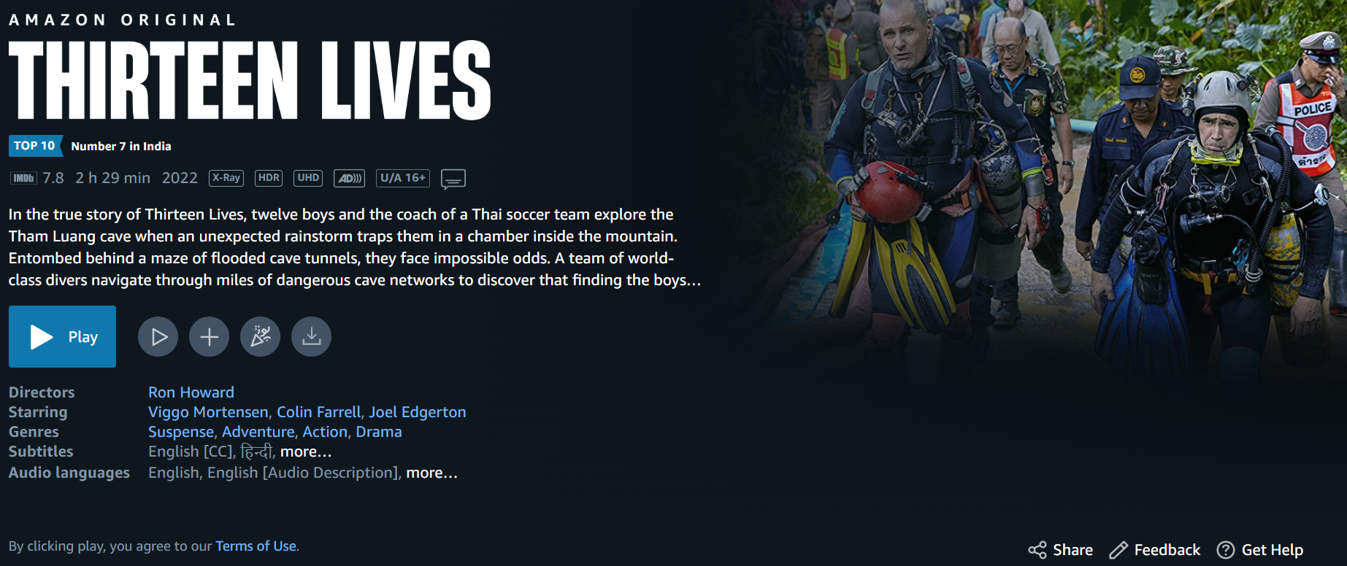

**CONTINUE WATCHING**

After that we have CONTINUE WATCHING section. This section is basically consist of movies that are watched before and yet to complete buy the user.

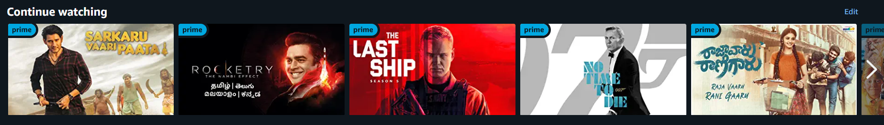

When we click the right arow we can see more movies.

After that we have **DRAMAS SECTION.**

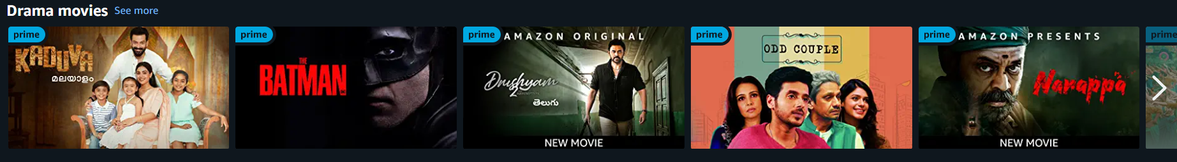

When we bring the courser on to the Image we can see the HOVER EFFECT as shown in the image below.

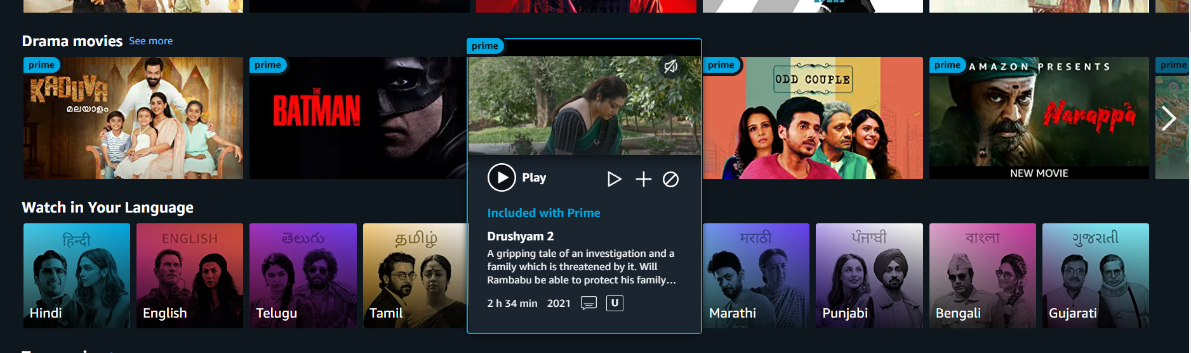

After that we have **WATCH IN YOUR LANGUAGE.**

This section provides the User to select his own comfortable language to watch the movie. 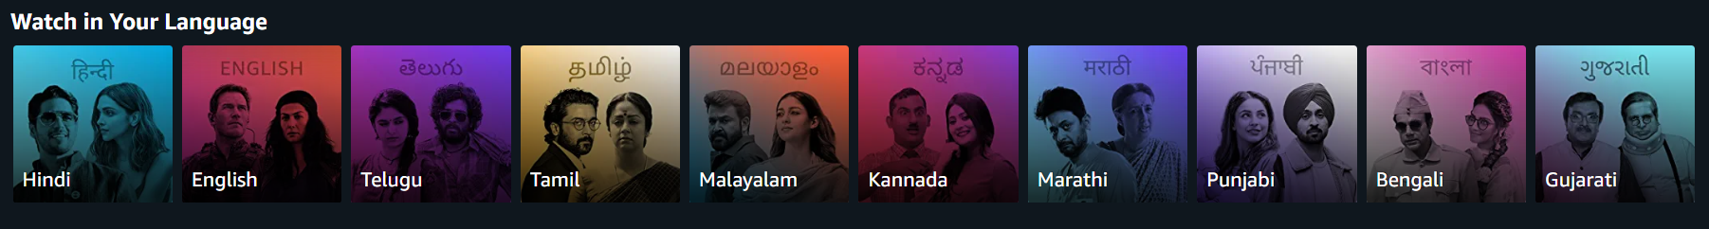

After thet we have several sections

* Recommended movies
* Subscribe to channels
* Amazon original series.
* Academy Award nominees and winners.
* Top Ten in India.
* Top movies.
* Thriller Movies.
* Filter based on Language.
* Action and adventures movies.
* Latest movies.
* Some other sections……..

**STORE**

Here we have movies for rent, we can watch movies only when we pay the rent.

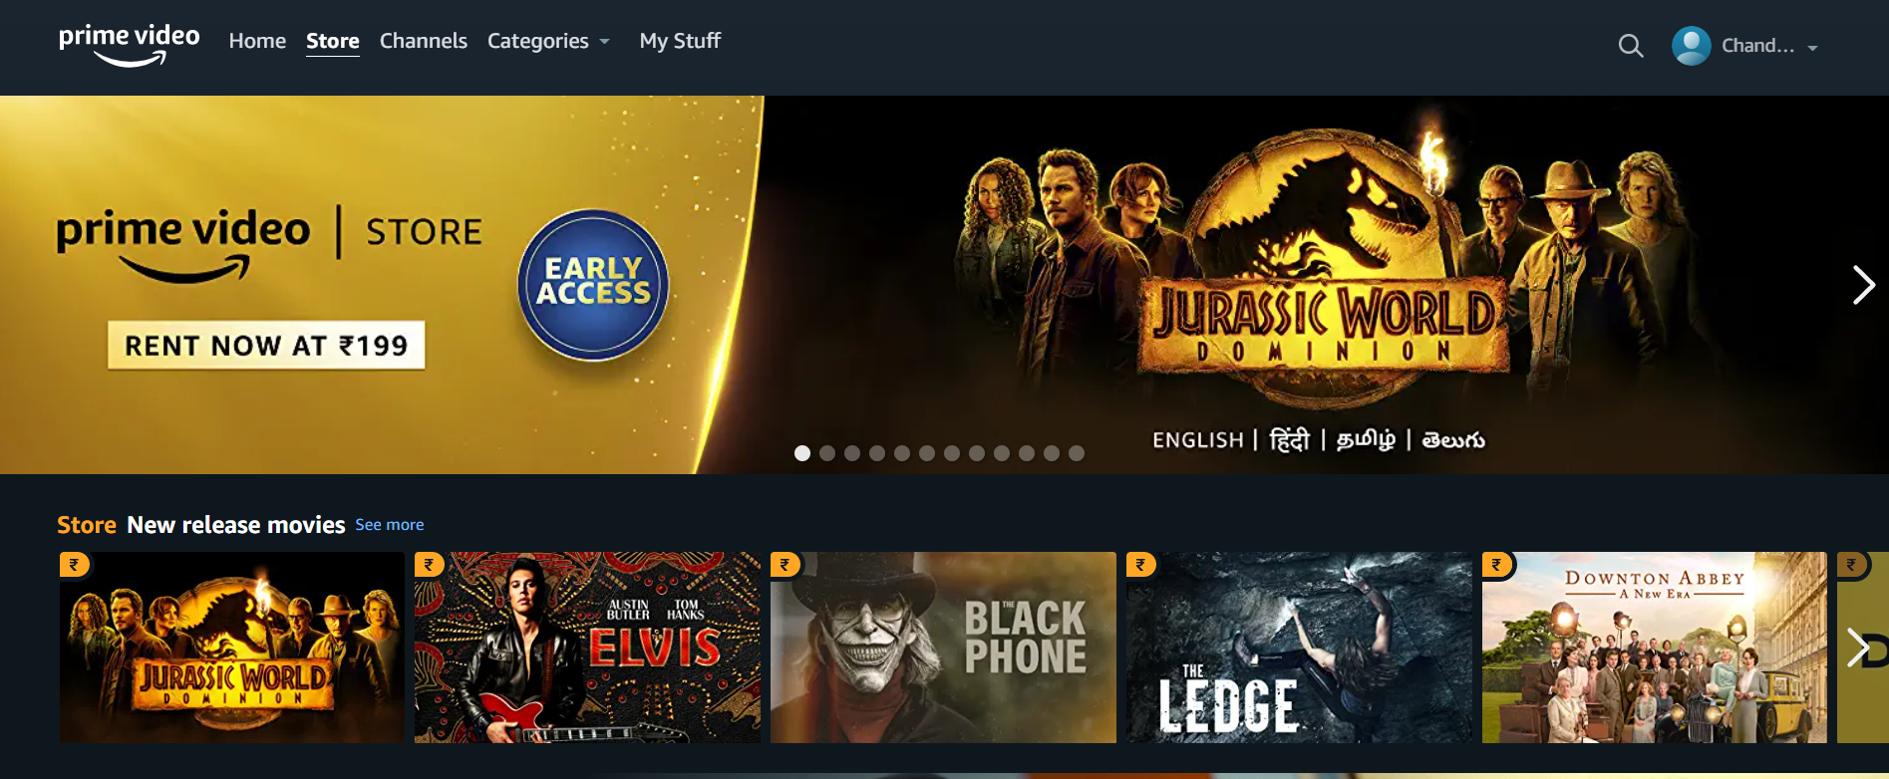

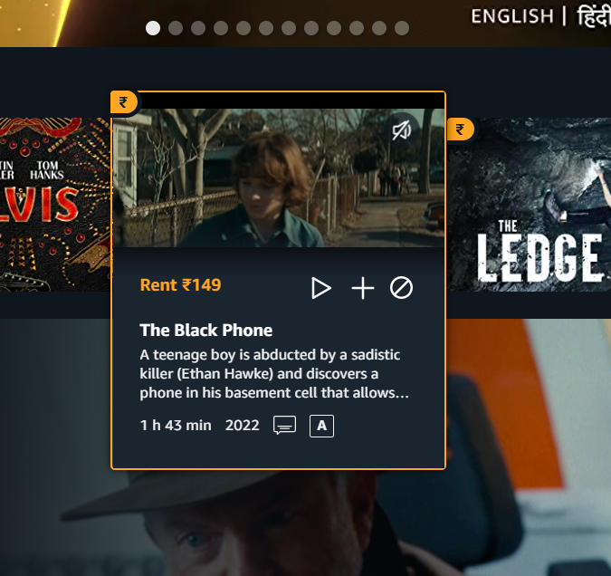

**USER INFORMATION**

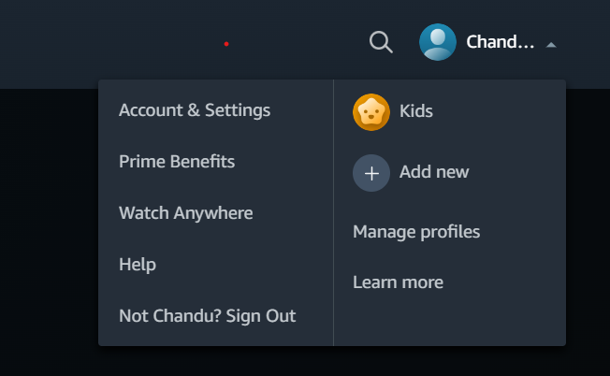

**FOOTER**

